**Brand Name : INTERWOOD**

Office chairs

# Dexo Mat Executive Chair

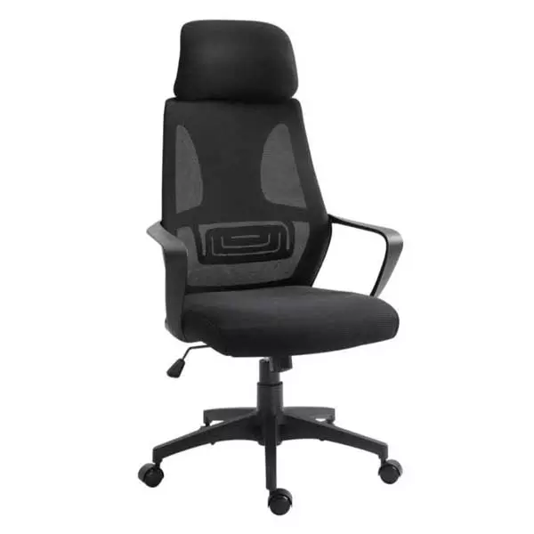**Description :**

**Top Quality Dexo Mat Executive Chair Photos & Videos**  
We provide original unedited photos and videos of Dexo Mat Executive Chair to our customers so that it is more convenient to make decision before placing an order online at chair.com.pk.

**Dexo Mat Executive Chair Quality Products**  
We provide a “Quality Product” for Dexo Mat Executive Chair to our customers. We send to our customer that he/she get a quality product.

**Best Designed Product to Customers**  
We will recommend the best models as per international standards, developed according to the market and customers; we suggest trendy design to the customers according to customers’ needs.

We also deal in bulk quantities order of [**Executive Chair**](https://chair.com.pk/product/dexo-mat-executive-chair/) so as in single piece too. We Deliver Dexo Mat Executive Chair in Lahore, Karachi, Faisalabad, Rawalpindi, Peshawar, Islamabad, and All Over Pakistan.

**Features:**

* Adjustable height, comfortable headrest, and wide armrests
* high-quality seat, wheel casters for easy movement
* 360-degree circular motion with tilting mechanism

**Rs. 17,500**